H.T No
Regulations:
A18

Sreenidhi Institute of Science and Technology
(An Autonomous Institution)
Code No: 7C354 Date: 08-Oct-2020 (FN)

B.Tech II-Year I-Semester External Examination, October - 2020 (Supplementary)
ANALOG ELECTRONIC CIRCUITS (CSE and it)

Time: 2 Hours Max.Marks:70

Note: a) No additional answer sheets will be provided.
b) All sub-parts of a question must be answered at one place only, otherwise it will not be valued.
c) Missing data can be assumed suitably.

ANSWER ANY FIVE QUESTIONS. EACH QUESTION CARRIES 14 MARKS.

1. | a) | Explain the formation of a PN junction diode with neat sketches. | [7M]
 | b) | Explain the operation of a PN junction diode in forward bias and reverse bias with all the necessary graphs. | [7M]
2. | a) | Derive the expression for stability factor S of a self bias circuit of BJT. | [7M]
 | b) | For the circuit shown below, find I_{C}, V_{E}, V_{CC}, V_{CE}, V_{B} and R₁.  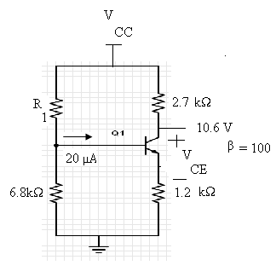 | [7M]
3. | a) | Derive expressions for current gain, input resistance and voltage gain of Common Emitter amplifier using small signal h-parameter model. | [7M]
 | b) | Calculate voltage gain, current gain and input resistance of the amplifier shown below. Assume h_{fe}=60 and h_{ie}=1.1kΩ  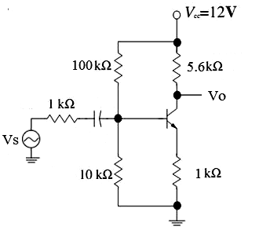 | [7M]
4. |  | Explain the construction and operation of N-channel MOSFET in enhancement and depletion modes with the help of static drain characteristics and transfer characteristics? | [14M]
5. | a) | Calculate voltage gain, input and output impedances of the amplifier shown below.  g_{m} = 2mA/V, r_{d} = 50K  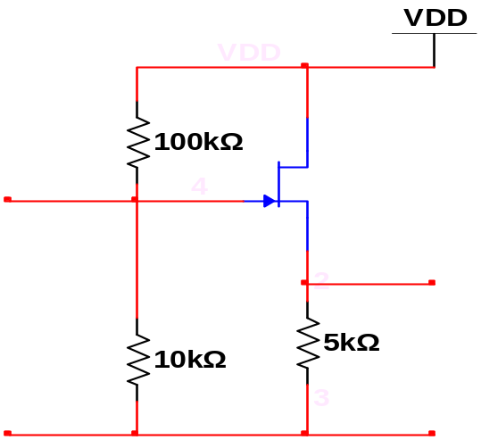  Vi  V0 | [7M]
 | b) | Explain the operation of common drain amplifier with neat sketches and derive the equations for Z_{i} , Z_{o} and A_{v}. | [7M]
6. | a) | Derive an expression for frequency of oscillations of a RC phase shift oscillator using BJT. | [7M]
 | b) | Draw and explain the working of Hartley oscillator circuit. | [7M]
7. | a) | Explain the operation of full wave rectifier with necessary waveforms. Derive V_{DC}, I_{DC}, ripple factor and efficiency for full wave rectifier. | [7M]
 | b) | Draw the frequency response of RC coupled amplifier | [7M]
8. | a) | The p-channel JFET has a I_{DSS} = -12mA, V_{P} = 5V and V_{GS} = 1.6V. Calculate I_{D}, g_{m} and g_{m0}. | [7M]
 | b) | Draw the small signal model for JFET Common source amplifier with self bias (bypassed R_{s}) and find Z_{i}, Z_{o} and A_{v}. | [7M]

-- 00 -- 00 –

